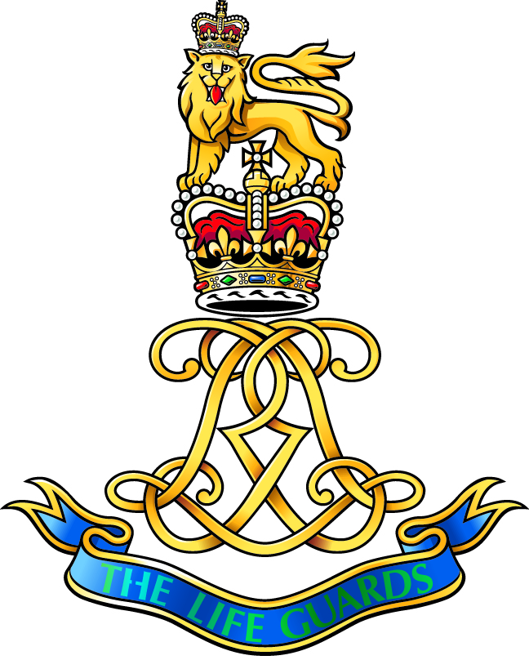
THE Life Guards Association
85th ANNUAL DINNER 2022 TICKET APPLICATION

The 85th Annual Dinner will be held at the Grand Connaught Rooms in London on Saturday, 28th May 2022 at 19:00 hrs. Dress: lounge suits, Regimental tie's, no medals.

Tickets are limited to members of the Association and official guests only, if you have any queries please contact me directly. This application form is available on the website.

There are 2 methods of payment:

Cheques – Please complete the below form and return completed to HHQ with your cheque. Once your cheque has been received and processed you shall receive a confirmation email and either receive your ticket by email or post. You may email the form back to HHQ if you wish.

Please make cheques payable to: The Life Guards Association Charitable Trust

BACs - Please use your Surname and last 4 of your army number as your Reference
Sort Code 30-11-75
Account No 21291060

Once you have made payment please email lg.regsec@householdcavalry.co.uk so that you may receive confirmation of payment and your e-ticket.

TO:  The Honorary Secretary  The Life Guards Association  Home Headquarters Combermere Barracks  Windsor  Berkshire  SL4 3DN | PLEASE SEND: |  | £
 | Officers serving & non-serving + spouse or partner @ £40.00 each If you are purchasing tickets for more than one person please provide their names.
 | Association members + Spouse/partner @ £35.00 each If you are purchasing tickets for more than one person please provide their names.
 | Donation to The Life Guards Association (Please see enclosed Gift Aid)
 | If you chose to make a donation can you please complete the attached Gift Aid Form it increases your donation by 25% | Total
FROM:

Service number…………………………………………………………………………………………………………….

Name:…………………………………............................................................................................ Address:………………………………………………………….……………………………………..………………...………………………………………………………………………………………………………………………………
Email address……………………………………………………………………………………………………………
Phone Number………………………………………………………………………………………………………….

Gift Aid declaration
Name of Charity: THE Life Guards Association Charitable Trust
Charity Number: 229144

Please treat

- The enclosed gift of £ as a Gift Aid donation; OR
- All gifts of money that I make today and in the future as Gift Aid donations; OR
- All gifts of money that I have made in the past 6 years and all future gifts of money that I make from the date of this declaration as Gift Aid donations.

- Please tick the appropriate box
You must pay an amount of Income Tax and/or Capital Gains Tax for each tax year (6 April one year to 5 April the next) that is at least equal to the amount of tax that the charity will reclaim on your gifts for that tax year.

Donor’s details

Title Initial(s) Surname

Home Address

Postcode Date

Signature

Please notify us if you:

- Want to cancel this declaration
- Change your name or home address
- No longer pay sufficient tax on your income and/or capital gains.

Tax claimed by the Charity

  - The Charity will reclaim 28p of tax on every £1 you gave up to 5 April 2008.
  - The Charity will reclaim 25p of tax on every £1 you give on or after 6 April 2008.
  - The Government will pay to the Charity an additional 3p on every £1 you give between 6 April 2008 and 5 April 2011. This transitional relief for the Charity does not affect your personal tax position.

If you pay income tax at the higher rate, you must include all your Gift Aid donations on your Self Assessment tax return if you want to receive the additional tax relief due to you.

Please return this form and any other correspondence to:

The Honorary Secretary The Life Guards Association, Combermere Barracks, Windsor, Berkshire SL4 3DN.

