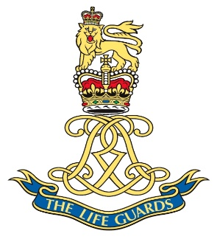

Last name ORR
First name(s) / Initial(s) Kenneth Crichton
Rank Tpr
Service Army
Service Number 19172159
Regiment THE LIFE GUARDS
Date of Birth 28/04/1929
Age 18
Date of Death 19/04/1948
Cemetery Name Ramleh Military Cemetery
Cemetery Address Palestine
Grave Section 17
Grave Row D
Grave Number 19
Included on the Armed Forces Memorial Yes
Included on Roll of Honour Yes

