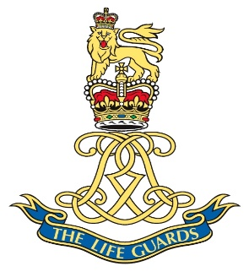

Last name YOUNG
First name(s) / Initial(s) Terence Jack
Rank Tpr
Service Army
Service Number 19180983
Regiment THE LIFE GUARDS
Date of Birth 09/05/1929
Age 18
Date of Death 21/04/1948
Cemetery Name Ramleh Military Cemetery
Cemetery Address Israel
Grave Section 17
Grave Row E
Grave Number 1
Included on the Armed Forces Memorial Yes
Included on Roll of Honour Yes

